|  |
| --- |
| Team Name Here |
| Project Title Here |
|  |

|  |
| --- |
| Team Member 1, Email Address  Team Member 2, Email Address  Team Member 3, Email Address  .....  ...  . |

# Project Feasibility

## Market Research & Product Background

Analysis of the existing market place with justification of genre, platform and proposed content. Demonstrate that your project choice is the result of informed decision making and planning.

## Target Audience

Who the game is aimed at ? How have you justified this decision ? What evidence is there to suggest your decisions are well informed ?

## License/Brand Analysis

A study of the license and brand elements potential of the game. Give consideration for new franchise potential and an analysis of existing materials to avoid copyright and legal issues.

## Statement of Differentiation

Statement of differentiation - how and why is your product unique i.e. not a copy of an existing product ?

# Game Design Documentation

## Detailed Game Concept

A more in depth look at the concepts outlined in your original project proposal document. Key story elements, genre, narrative and product features.

## Game & Product Structure

Describe the key areas of your game such as levels & locations along with all game menus and sub-features. How exactly will areas of play be broken down ? How are they related ? How will the player move from one element to another (including menu and feature navigation).

## Gameplay Mechanics

A more in depth explanation of the mechanics that define your game play. This should consider everything from user input characteristics, to weapon systems, camera systems and objective tracking.

## Gameplay Goals & Challenges

A detailed overview of the required victory conditions and how it can be attained. Include any puzzle mechanics and physical challenges that apply.

## Product Asset List

Provide a definitive and descriptive list of all elements including story, characters, objects and locations, FX, SFX etc. Try to be as descriptive as possible here.

# Technical Design Documentation

## Key Technical Challenges

Give an overview of the expected technical challenges and development risks related to the proposed project.

## Workflow & Dependencies

Provide a breakdown of as many game features as possible, sorted by priority and task dependency. This should be completed for each major team role i.e. programming, technical art, audio etc.

## Technology & Applications

Provide a detailed breakdown of all core technologies that will be used during the development of the project. You should specify the exact version of the engine you are using, and list any critical plugins that may be required. You should also give consideration to hardware such as VR or other specific forms of input/display devices that your game may require use of.

## Technology Implementation Overview

Provide a written overview of all technical feature of your game. You should provide an explanation of how each feature was implemented and an overview of its architecture. This should be completed for ALL functioning parts of your game wherever possible.

# Art Style Documentation

## Key Visual Design References: Game Assets

Based on the Asset List you provided in section 2.5, provide an initial concept design for as many of the items as possible. This can then be used to further develop the “look and feel” of all objects within your game. Some examples images are as follows:

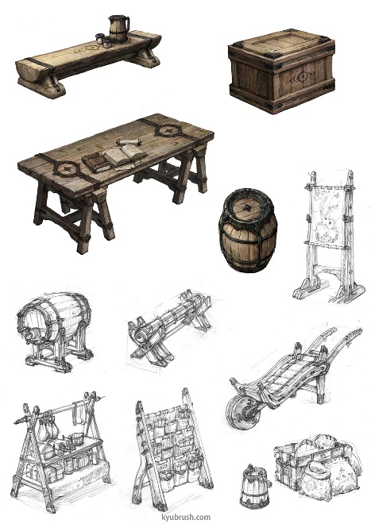 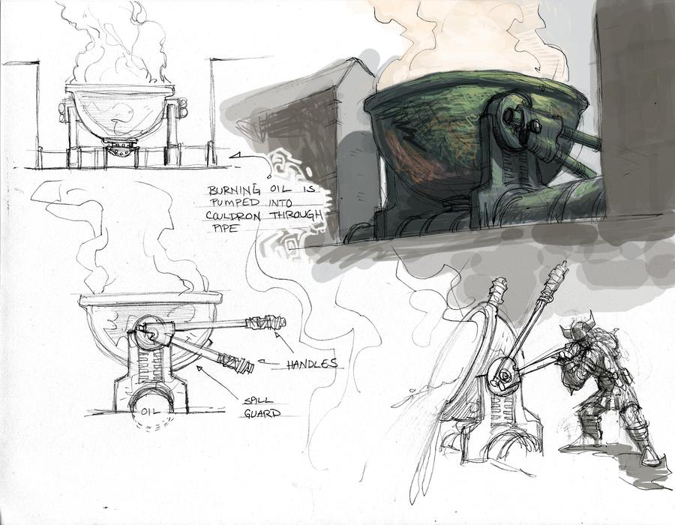

## Key Visual Design References: Environment Art

In reference to the game structure information you provided in section 2.2, provide some initial layout and map designs that will be used to further the development of your scenes. Try to give some consideration for style and mood. A basic example of map design is as follows:

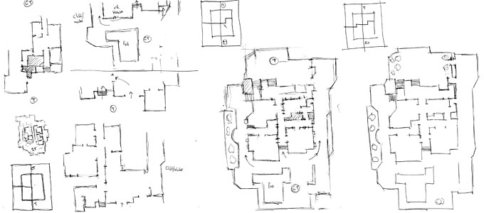

# Pendulum Analysis Documentation

## Core Game Loop Design

The core game loop revolves around survival of a hostile space station through various different movement mechanics and survival elements. The goal of escaping the space station will be well defined at the beginning through the artificial intelligence of the space station teasing the player about their current failure to escape. Players will have to manage their oxygen levels whilst solving environmental puzzles and avoiding the artificial intelligence efforts to undermine the player. Clear feedback will be provided to the player through the artificial intelligence, who communicates with the player throughout the game as the antagonist.

## Real-Time Engagement Design

On a second to second basis, there will be multiple interactions that take place to allow for maximum player engagement. The player will need to manage their oxygen by finding oxygen sources, whilst avoiding hostile environments. The management of oxygen levels will be restricted to certain areas, as will the hostile environment. This provides potential for different short term interactions to keep the player at a high level of engagement.

Minute to minute engagement revolves around one main goal for the player to aim to fulfill. This goal is the traversal of the space station through various movement mechanics and the progression through distinct sections of the space station.

## Long Term Engagement Model

The engagement model for hour to hour gameplay involves the introduction of new movement mechanics. These movement mechanics will be provided to the player following milestones in the progression through the space station. Each new movement mechanic will be utilised in progressively more complex situations alongside previous mechanics. This ramp in difficulty provides a more engaging design for the player on an hour to hour basis. As the player gets to grips with mechanics, a new one is introduced to keep the player interested. Players will be rewarded with achievements after accomplishing certain milestones in the story, or for accessing hidden locations in the space station.

Year to year engagement with the game requires the release of additional content. Content is easily expanded on with a space station, as new characters or areas can be introduced. A time trial mode would be a very simple addition that introduces a new competitive aspect to the game.

**Discovery**

The target market will find us through our engaging visual design on digital store fronts and the drive from this market to seek out interesting game mechanics.

**Download & Adoption**

The game design has a broad appeal to most, due to the intrigue and potential of a space station setting.

**Onboarding & Exploration**

Engaging mechanics that push players to mentally invest themselves in the game are going to draw users into playing.

**Re-use & Purchase**

**Engagement Loop**

CTA > Movement based puzzle mechanics > AI enemy response/visual spectacle > Positive Player Emotion

# Project Management & Development Timeline

## Proposed Development Plan

Provide a draft development timeline for the project as a whole - include ALL aspects of work ranging from research, development, report and presentation areas. Semesters 1 and 2.

## Schedule of Meetings

Provide a detailed schedule of management meetings for semester 1 and 2. How will you address the key elements from your primary timeline outlined above ?

## Personal Development Plans

Provide a draft project plan for each team member - at this stage it **does not** have to cover the project from beginning to end, but **should** include a **detailed** breakdown of work for semester 1.

## Initial Sprint Management

Provide a detailed plan for your first project sprint. Include dates, estimates, task priorities and dependencies.